Russell George
Veteran Missionary in Argentina

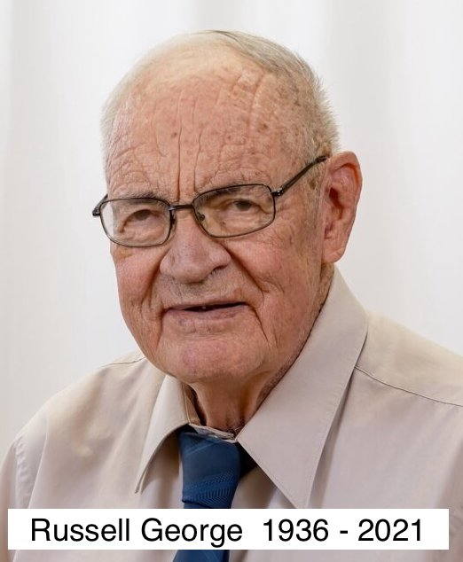

Some of his accomplishments during his 37 years in Argentina as a missionary:

He started three churches.

He held many Evangelistic campaigns to reach lost souls.

He discipled many converts with an organized plan.

He trained men to serve the Lord full time as pastors and leaders.

He preached in many areas all over Argentina, helping other pastors in their works.

He has written hundreds of articles in Spanish and English on many subjects. His Web Page www.randrforchristianliving.org

He wrote a book - To God Be The Glory - a personal autobiography of his life. It is listed on www.amazon.com

He has influenced many more missionaries to go to Argentina!

He worked in a jail ministry here in Greenville, MO, the last 8 years by going every Saturday morning to talk to the inmates, witness to them, pray with them, and disciple new converts.

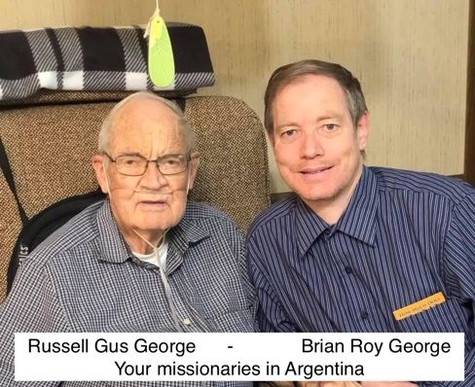
If you would like to give a MEMORIAL gift in memory of my Dad, it could be used for Bibles and Gospel Tracts to be given away freely in Argentina and surrounding countries. One Spanish Bible costs $2.30 and a Gospel tract cost $.013 each. I would like to see One Million Gospel Tracts Printed in Honor of my Dad and 1,000 Bibles distributed. As a teenager I passed out many gospel tracts with my Dad. We would often pass out up to 2,000 gospel tracts in over an hour.

For Souls,
Brian Roy George and Family

Memorial Gift for Bibles and Gospel Tracts – Send funds to:
Fundamental Baptist Missions International (FBMI) / Designated “Bibles and Gospel Tracts for Argentina”
507 State Street
Hammond, IN 46320. /. www.fbmi.org

Russell George Address:
407 Pine Lane
Silva, MO 63964

E-mail - Brian Roy George - GeorgeFamilyArgentina@gmail.com web: www.ByFaithLetsGoForward.org

